Why do Tectonic plates move?
According to the theory of Plate Tectonics, the earth's tectonic plates are constantly moving, like giant 'rafts' on top of the semi-molten mantle below. This movement is very slow and varies from less than 2.5 cm per year to over 15 cm per year.
The movement of the earth's crustal plates is believed to be due to convection currents. The convection currents occur in the semi-molten mantle and the plates on the surface of the earth are carried along by the current. These convection currents are created by heat from within the earth - much of which is generated by radioactive decay of atoms in the core.
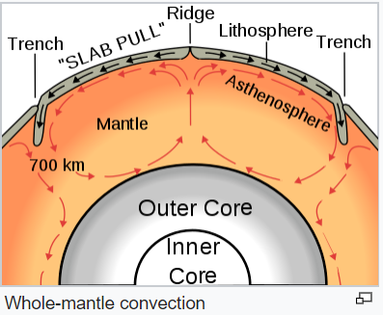
So how do convection currents cause plate movements?
As semi-molten rock in the mantle is heated, some parts become hotter than others. The hotter parts are less dense than the mantle around it, so it rises. As it reaches the crust above, it spreads out, moving the plates above with it. As the semi-molten rock then cools, it gradually sinks back down to be re-heated (see the circular convection currents in the diagram above).

Questions
- How is the heat inside the earth generated?

- Why does the hottest rock in the mantle rise and the coolest rock sink?

- If the plates are floating and moving with these convection currents what do you think is happening on the surface of the earth where plates are moving apart (like at the very top of the diagram)?

